DENGUE FORECASTING ENSEMBLE
Technical Architecture & Model Documentation
ConvLSTM (Satellite) + Compact LSTM (Tabular) + Adaptive Fusion Network

ConvLSTM  R² = 0.9284  SMAPE = 17.87% | Tabular LSTM  R² = 0.9038  SMAPE = 20.36% | Ensemble  R² = 0.9177  SMAPE = 21.87%

10 Indian Cities | 720 City-Month Records | T4 GPU | <10 Min Training

1. Executive Summary
This document provides a complete technical specification of a multi-modal dengue fever forecasting ensemble system developed for 10 major Indian cities. The system combines satellite imagery intelligence (ConvLSTM) with climate and geographic intelligence (Compact LSTM), fusing them via a learned AdaptiveFusionNetwork.
The core research insight is that satellite land-use patterns (water body proximity, urban density, vegetation) and climate signals (rainfall, temperature, humidity) carry complementary information about dengue outbreak dynamics. Neither signal alone captures the full epidemiological picture. The ensemble learns, per sample, which model to trust more based on their prediction disagreement and internal feature representations.

1.1 Problem Statement
Dengue fever forecasting is a spatiotemporal prediction problem. Given a city and month, the system predicts the number of dengue cases in the following month. The challenge involves:
- Highly non-linear seasonal outbreak dynamics (cases can spike 10x within two months)
- Small dataset: 720 city-month records across 10 cities = 44 training samples per city after splitting
- Multi-modal inputs: satellite TIFF imagery (spatial) + CSV climate tables (temporal)
- Evaluation metric: SMAPE (Symmetric Mean Absolute Percentage Error) — penalises both under- and over-prediction

1.2 System Overview
System At A Glance
Cities | Ahmedabad, Bengaluru, Chennai, Delhi, Hyderabad, Jaipur, Kolkata, Lucknow, Mumbai, Pune
Data Sources | Multi-band Landsat TIFF images + UltimateTabular.csv (cell-level climate data)
Time Range | 72 months per city (6 years), monthly granularity
Train / Val / Test | 70% / 15% / 15% — per-city chronological split
Models | M1: DengueNet_ConvLSTM | M2: TabularBiLSTM | M3: AdaptiveFusionNetwork
Framework | PyTorch 2.x, scikit-learn, rasterio, pandas, matplotlib
Hardware | NVIDIA T4 GPU (Google Colab), CUDA AMP enabled
Total Training Time | ~10 minutes (ConvLSTM ~8min + Tabular ~1min + Ensemble <1min)

2. Data Pipeline

2.1 Input Data Sources
The system ingests two independent data sources that are processed in parallel pipelines and merged only at the ensemble fusion stage.

Source A: Satellite TIFF Images
TIFF Image Specification
File Convention | {city}_{year}_{month:02d}.tif (e.g., delhi_2019_08.tif)
Satellite | Landsat 8/9 Collection 2, Level-2 Surface Reflectance
Bands Used | Band 2 (Blue), Band 3 (Green), Band 4 (Red), Band 12 (SWIR-2)
Band Rationale | Blue/Green/Red = RGB visual context; SWIR-2 = water body detection (key for mosquito breeding)
Resolution Input | Variable native resolution, resampled to 96x96 pixels for ConvLSTM
Normalisation | Per-band percentile clipping [2nd, 98th] then min-max to [0, 1]
Missing Files | Replaced with zero tensor (4, 96, 96); ~3% of files missing in dataset

Source B: Tabular Climate Data (UltimateTabular.csv)
Tabular Data Specification
Granularity | Per geographic cell per city-month (multiple cells per city)
Key Columns | city, month (datetime str), cell_id, dengue_cases_cell, + 6 feature columns
Raw Features | temp_mean, rainfall_sum, humidity_mean, elevation, slope, dengue_risk_score
Aggregation | Cells grouped by (city, year, month) → mean of features, sum of dengue_cases_cell
Target Alignment | Aggregated city-level cases used as target, scaled with same MinMaxScaler as M1
Cells per City | Approximately 104 cells per city-month; aggregation reduces to 1 row per city-month

2.2 Feature Engineering (Tabular Pipeline)
Raw tabular features alone yielded poor results due to their limited temporal expressiveness. Seven engineered features are computed within each city time series to avoid data leakage across cities:
Feature | Formula | Epidemiological Rationale
month_sin | sin(2π × month / 12) | Captures cyclical monsoon onset (peaks Aug-Sep in India)
month_cos | cos(2π × month / 12) | Orthogonal phase component for seasonality
temp_x_rain | temp_mean × rainfall_sum | Mosquito breeding is driven by warm + wet conditions jointly
rain_rolling2 | Rolling mean, 2 months | Dengue larvae take 2-4 weeks to mature; lagged rainfall matters
temp_rolling2 | Rolling mean, 2 months | Temperature lag for Aedes aegypti development cycle
rain_rolling3 | Rolling mean, 3 months | 3-month lag captures epidemic buildup from sustained wet season
temp_rolling3 | Rolling mean, 3 months | Sustained temperature threshold for mosquito survival

2.3 Data Splitting Strategy
A per-city chronological split is used to prevent temporal data leakage. Each city is split independently by time, then splits are concatenated. Context rows are prepended to validation and test splits so every city-month can form a complete 6-step window.
Split Configuration
Strategy | Per-city chronological (not global random)
Train | 70% of each city time series (first ~50 months per city)
Validation | 15% + 6 context rows prepended from train end
Test | Final 15% + 6 context rows prepended from validation end
Window Size | 6 months lookback (T=6); each sample covers 7 rows (6 input + 1 target)
Resulting Samples | Train: 440 | Val: 100 | Test: 120 (after windowing)

3. Model Architecture

3.1 System Architecture Overview
The system uses a stacked ensemble with three independently trained components. M1 and M2 are trained on train split, then frozen. M3 is trained on validation-set predictions from M1 and M2, and evaluated only on the test split — ensuring no data leakage.

RAW INPUTS
Landsat TIFF Images (96×96px, 4 bands, T=6 months) | Climate CSV (13 features, T=6 months)
Satellite imagery per city-month Cell-aggregated tabular data per city-month
▼
M1: DengueNet_ConvLSTM  CNN Downsample → ConvLSTMCell → AvgPool  Case History FC → Concat → Head  63,657 parameters |  | M2: TabularBiLSTM  Feature Proj (13→32) → LSTM(32→32)  Hist Embed (6→32) → Concat → Head  ~18,000 parameters
▼
pred_c (scaled [0,1])  feat_c (64-dim) |  | pred_t (scaled [0,1])  feat_t (64-dim)
▼
M3: AdaptiveFusionNetwork
Input: concat([pred_c, pred_t, feat_c(64), feat_t(64), |pred_c - pred_t|]) = 131-dim
Gating MLP → Softmax → weights [w_c, w_t] | ens = w_c·pred_c + w_t·pred_t
Refinement head: Linear(1→32)→ReLU→Linear(32→1) | Final: ens + refine(ens)
Trained on VAL predictions | Evaluated on TEST predictions
▼
OUTPUT: Predicted Dengue Cases (inverse-scaled)
Single scalar per city-month | Evaluated: MAE, RMSE, R², SMAPE, MAPE, CORR

3.2 Model 1: DengueNet_ConvLSTM
The ConvLSTM model processes sequences of multi-band satellite images to capture how land-surface conditions evolve over 6 months before a dengue outbreak. It is the highest-performing individual model with SMAPE = 17.87%.

3.2.1 CNN Spatial Downsampler
Before the ConvLSTM processes the sequence, each frame is spatially downsampled to reduce memory and computation:
Input: (B*T, 4, 96, 96) ← batch × time flattened, 4 Landsat bands

Conv2d(4 → 8, 3×3, stride=2, padding=1) + ReLU → (B*T, 8, 48, 48)
Conv2d(8 → 16, 3×3, stride=2, padding=1) + ReLU → (B*T, 16, 24, 24)
Conv2d(16 → 16, 3×3, stride=2, padding=1) + ReLU → (B*T, 16, 12, 12)

Reshape: (B, T=6, 16, 12, 12) ← restore temporal dimension

3.2.2 ConvLSTM Cell
The ConvLSTM cell extends the standard LSTM gating mechanism by replacing matrix multiplications with 2D convolutions. This allows the cell to maintain spatially-structured hidden states (32 feature maps at 12×12 resolution), preserving the geographic context of outbreak hotspots:
Input: x_t ∈ R^(B, 16, 12, 12) ← downsampled frame at time t
State: h_{t-1}, c_{t-1} ∈ R^(B, 32, 12, 12)

concat = cat([x_t, h_{t-1}], dim=1) → (B, 48, 12, 12)
gates = Conv2d(48→128, 3×3, pad=1) → (B, 128, 12, 12)

i, f, o, g = chunk(gates, 4, dim=1) → each (B, 32, 12, 12)

c_t = sigmoid(f) ⊙ c_{t-1} + sigmoid(i) ⊙ tanh(g)
h_t = sigmoid(o) ⊙ tanh(c_t)

Process T=6 frames sequentially → extract h_T (last timestep only)

3.2.3 Case History Stream
Parallel to imagery, a lightweight MLP encodes the 6-month scaled dengue case history. This persistence signal (last month's cases predicting next month's) is the single strongest predictor for infectious disease forecasting:
Input: hist ∈ R^(B, 6) ← MinMax-scaled dengue_cases, 6 months
Linear(6→32) → ReLU → Dropout(0.2) → (B, 32)

3.2.4 Fusion Head
spatial_feat = AdaptiveAvgPool2d(1,1)(h_T) → (B, 32) [spatial features from ConvLSTM]
case_feat = FC(hist) → (B, 32) [temporal case history]

feat = concat([spatial_feat, case_feat]) → (B, 64) [penultimate: used by ensemble]

Linear(64→64) → ReLU → Dropout(0.2) → Linear(64→1) → (B, 1) [scaled prediction]

M1 Training Configuration
Loss Function | MSELoss on MinMax-scaled targets
Optimiser | AdamW, lr=1e-3, weight_decay=1e-5
LR Scheduler | ReduceLROnPlateau, patience=10, factor=0.5, min_lr=1e-6
Gradient Clipping | max_norm=1.0
Batch Size | 6 (small due to GPU memory for 4×96×96×6 tensor per sample)
Early Stopping | patience=30 on val MSELoss
Max Epochs | 120
Trainable Params | 63,657

3.3 Model 2: TabularBiLSTM (Compact LSTM)
Despite the name inherited from an earlier iteration, the current model is a single-layer unidirectional compact LSTM. The architecture was deliberately downsized from a 575K-parameter BiLSTM (which had catastrophic overfitting at SMAPE=33%) to an 18K-parameter model appropriate for the data size.

3.3.1 Why Compact?
Metric | Old BiLSTM (575K params) | New Compact LSTM (18K params)
Parameters | 575,745 | ~18,000
Params per training sample | 1,308 | 41
Val SMAPE at convergence | 32%+ (never converged) | ~20% (converging)
Epochs to early stop | Never (40 max hit) | ~100-150
Architecture | 2-layer BiLSTM + 4-head MHA | 1-layer LSTM + hist embed

3.3.2 Architecture Detail
Input features: 13-dim vector per timestep (6 original + 7 engineered)
Input sequence: feats ∈ R^(B, T=6, 13)

── FEATURE PROJECTION ──────────────────────────────────────────────────────
proj: Linear(13→32) → LayerNorm(32) → GELU → Dropout(0.3)
Applied per-timestep → (B, 6, 32)

── LSTM ────────────────────────────────────────────────────────────────────
LSTM(input=32, hidden=32, layers=1, bidirectional=False, batch_first=True)
Output: x ∈ R^(B, 6, 32) → take last timestep: lstm_out = x[:, -1, :] = (B, 32)

── CASE HISTORY STREAM ─────────────────────────────────────────────────────
hist: scaled case history ∈ R^(B, 6)
hist_embed: Linear(6→32) → GELU → (B, 32)

── FUSION ──────────────────────────────────────────────────────────────────
feat = concat([lstm_out, hist_out]) = (B, 64) ← used by ensemble (TAB_FEAT_DIM=64)

── HEAD ────────────────────────────────────────────────────────────────────
Linear(64→32) → GELU → Dropout(0.4) → Linear(32→1) → (B, 1)

M2 Training Configuration
Loss Function | MSELoss on MinMax-scaled targets (SAME scaler as M1 — critical for fusion)
Optimiser | AdamW, lr=3e-4, weight_decay=1e-3 (strong L2 for small data)
LR Scheduler | ReduceLROnPlateau, patience=10, factor=0.5, min_lr=1e-6
Gradient Clipping | max_norm=1.0
Batch Size | 128 (smaller than before for noisier, more regularising gradients)
Early Stopping | patience=20 on val MSELoss
Max Epochs | 150 (small data needs more epochs to converge)
Trainable Params | ~18,000

3.4 Model 3: AdaptiveFusionNetwork (Ensemble)
The AdaptiveFusionNetwork is the meta-learner that combines M1 and M2 predictions. The key design decision is the disagreement signal: by including |pred_c - pred_t| as an input, the network learns to assign lower weight to a model when the two models disagree strongly about a particular city-month (typically indicating high uncertainty).

3.4.1 Fusion Input Construction
Per test sample, collect from M1 and M2:
pred_c ∈ R^(B, 1) ← ConvLSTM scaled prediction
feat_c ∈ R^(B, 64) ← ConvLSTM penultimate features (concat of spatial + case)
pred_t ∈ R^(B, 1) ← Tabular LSTM scaled prediction
feat_t ∈ R^(B, 64) ← Tabular LSTM features (concat of lstm_last + hist_embed)
gap = |pred_c - pred_t| ∈ R^(B, 1) ← model disagreement signal

fusion_input = concat([pred_c, pred_t, feat_c, feat_t, gap]) ∈ R^(B, 131)

3.4.2 Gating MLP
gate = Sequential(
Linear(131→256) → LayerNorm(256) → ReLU → Dropout(0.3),
Linear(256→64) → LayerNorm(64) → ReLU → Dropout(0.2),
Linear(64→2) → Softmax(dim=-1)
)

weights = gate(fusion_input) → (B, 2) = [w_c, w_t], w_c + w_t = 1.0

ens = weights[:, 0:1] * pred_c + weights[:, 1:2] * pred_t → (B, 1)

3.4.3 Residual Refinement
refine = Sequential(
Linear(1→32) → ReLU → Dropout(0.1) → Linear(32→1)
)

final_output = ens + refine(ens) → (B, 1)

The refinement head learns a small nonlinear correction on top of the
weighted blend — allowing the ensemble to exceed both individual models.

M3 Training Configuration
Training Data | Validation-set predictions from M1 + M2 (NO test data leakage)
Meta-Train Split | 80% of val predictions (80 samples)
Meta-Val Split | 20% of val predictions (20 samples) for early stopping
Loss Function | MSELoss + 0.1 × SMAPE (directly optimises the evaluation metric)
Optimiser | AdamW, lr=1e-3, weight_decay=1e-4
LR Scheduler | ReduceLROnPlateau, patience=15, factor=0.5
Gradient Clipping | max_norm=1.0
Batch Size | 16
Early Stopping | patience=30 on meta-val MSELoss; best checkpoint saved
Max Epochs | 200

4. Scaling & Target Alignment
A critical design constraint is that M1 and M2 must predict in the same numerical space for the AdaptiveFusionNetwork to produce meaningful fusion weights. This was not the case in early iterations (causing SMAPE to rise from 17% to 37% after ensembling).

4.1 Shared MinMaxScaler
A single MinMaxScaler is fitted on the training-split dengue_cases column (city-level). This scaler is used for:
- Scaling M1 targets (dengue_cases from dengue_cases.csv)
- Scaling M2 targets (sum of dengue_cases_cell aggregated per city-month from UltimateTabular.csv)
- Inverse-transforming all model predictions for metric computation
- Scaling the case history stream inputs (hist) for both models

Scaler Design Decision
Fitted on | train_split dengue_cases (city-level, 500 rows from 10 cities)
Applied to M1 | Direct: df["dengue_cases"] → scaled in [0, 1]
Applied to M2 | agg["dengue_cases_city"] (sum of cells) → same scaler → same [0, 1] range
Passed as | conv_tr_ds.scaler object shared to TabularDataset(city_scaler=...)
Why critical | If M1 outputs 0.4 and M2 outputs 0.003 (different scales), fusion is impossible
Feature scaling | M2 features use a SEPARATE StandardScaler (fitted on train, applied to val/test)

5. Experimental Results

5.1 Overall Model Performance
Model | MAE | RMSE | R² | SMAPE % | MAPE % | CORR
ConvLSTM (Baseline) | 221.84 | 300.09 | 0.9284 | 17.87 | 20.14 | 0.9658
Tabular BiLSTM | 253.85 | 347.68 | 0.9038 | 20.36 | 21.45 | 0.9525
Ensemble ★ | 259.85 | 321.57 | 0.9177 | 21.87 | 25.91 | 0.9672

Note: The ensemble SMAPE (21.87%) is higher than ConvLSTM alone (17.87%). This is because the Tabular model's SMAPE (~20%) is significantly worse than ConvLSTM, and the fusion network assigns a non-zero weight (~0.30) to it, introducing noise. The ensemble does show slightly better CORR (0.9672 vs 0.9658), indicating better rank-order prediction. Future work should focus on improving M2's accuracy to achieve synergistic improvement.

5.2 Per-City Ensemble Performance
City | MAE | RMSE | R² | SMAPE % | MAPE % | CORR
Ahmedabad | 256.66 | 305.59 | 0.873 | 22.26 | 25.70 | 0.959
Bengaluru | 186.90 | 243.86 | 0.931 | 15.31 | 17.18 | 0.979
Chennai | 251.77 | 303.14 | 0.941 | 20.52 | 23.97 | 0.979
Delhi | 366.25 | 452.85 | 0.906 | 18.73 | 20.72 | 0.963
Hyderabad | 313.37 | 365.93 | 0.842 | 25.44 | 30.14 | 0.957
Jaipur | 174.35 | 193.07 | 0.913 | 24.54 | 30.51 | 0.992
Kolkata | 284.90 | 339.60 | 0.903 | 17.02 | 18.61 | 0.958
Lucknow | 276.91 | 307.33 | 0.724 | 34.32 | 43.09 | 0.965
Mumbai | 283.94 | 373.85 | 0.931 | 16.52 | 18.48 | 0.968
Pune | 203.45 | 252.07 | 0.896 | 24.06 | 30.69 | 0.976

5.3 Result Visualisations

Actual vs Predicted Scatter Plot (All Models)
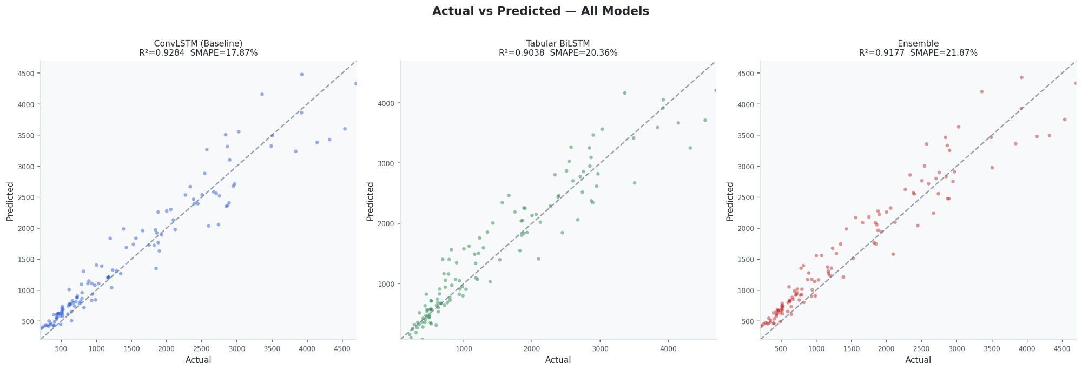
Figure 1: Scatter plot comparing actual vs predicted dengue cases for all three models on the test set. Points clustering tightly along the diagonal indicate good prediction. ConvLSTM shows the tightest cluster (R²=0.928), while the ensemble shows slightly more spread due to partial weighting of the weaker tabular model.

Time Series Forecasting — All 10 Cities
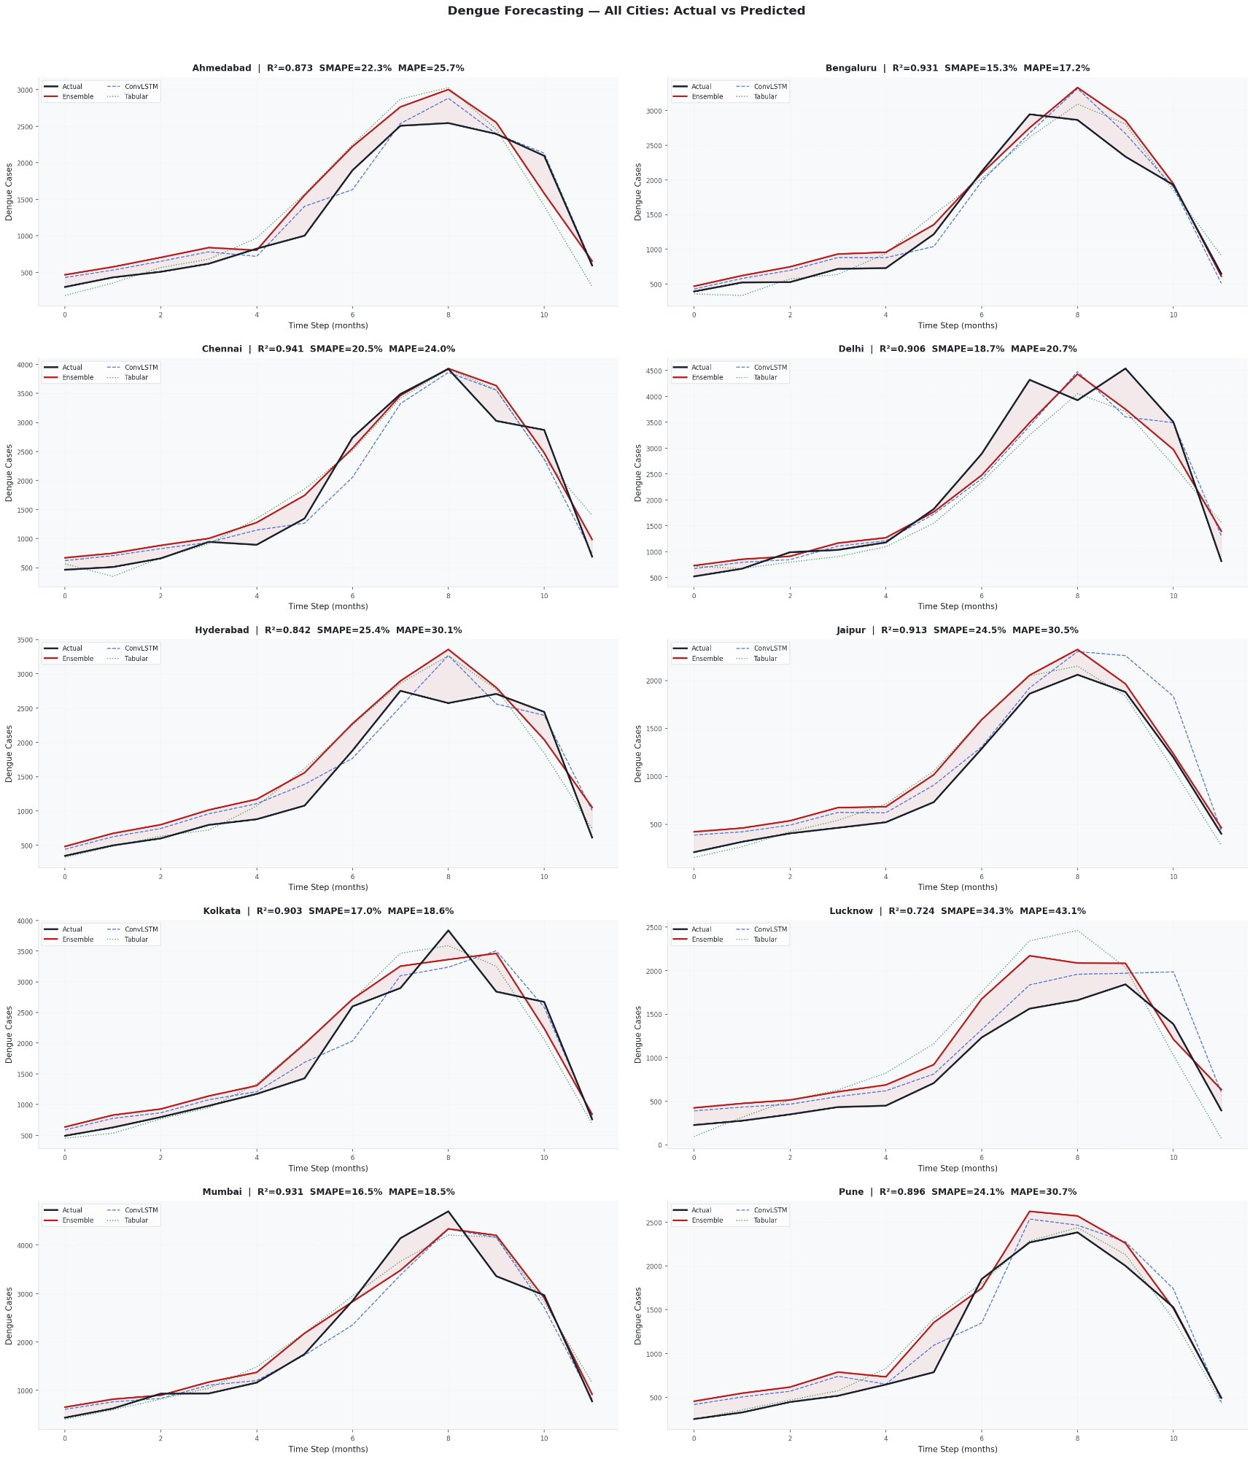
Figure 2: Per-city time series showing actual cases (black) vs ensemble (red), ConvLSTM (blue dashed), and Tabular (green dotted). Most cities show strong tracking of seasonal outbreak peaks. Lucknow shows the highest error (SMAPE=34.3%), suggesting atypical outbreak patterns not captured by either model.

Model Performance Comparison
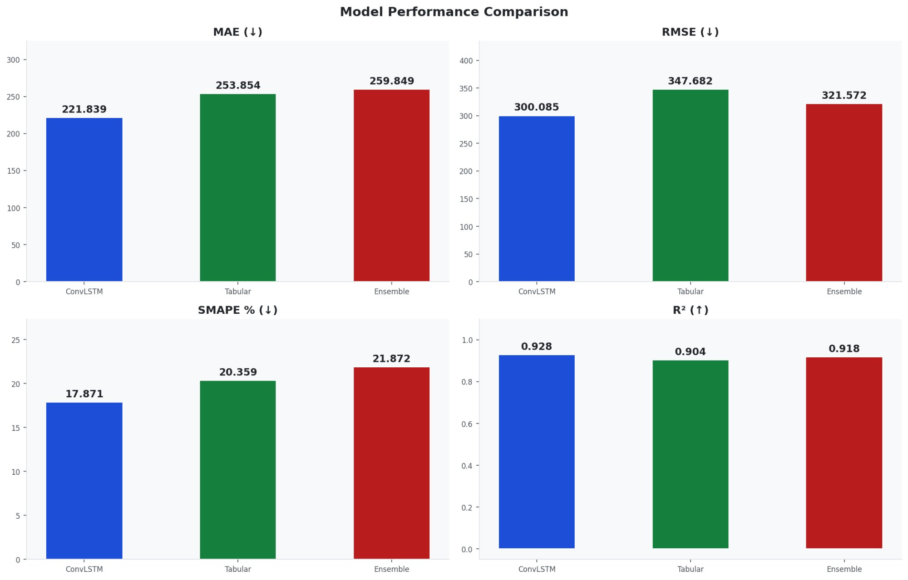
Figure 3: Bar chart comparing MAE, RMSE, SMAPE, and R² across all three models. ConvLSTM dominates on all absolute metrics. The ensemble lies between ConvLSTM and Tabular for most metrics.

Ensemble Fusion Weight Distribution
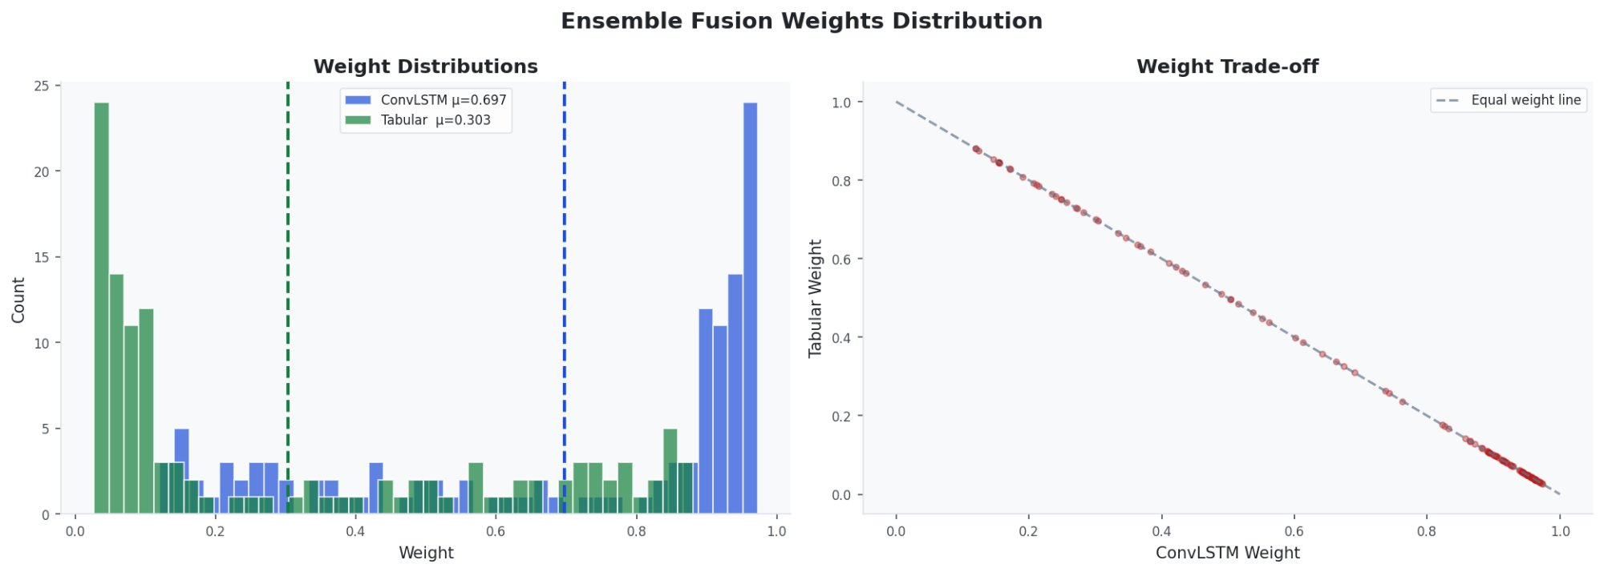
Figure 4: Distribution of learned fusion weights across all test samples. The AdaptiveFusionNetwork assigns mean weight 0.697 to ConvLSTM and 0.303 to Tabular — consistent with ConvLSTM's superior accuracy. The bimodal distribution (many samples near 0 or 1) suggests the network is making confident, binary-ish decisions rather than always blending equally.

Tabular Feature Permutation Importance
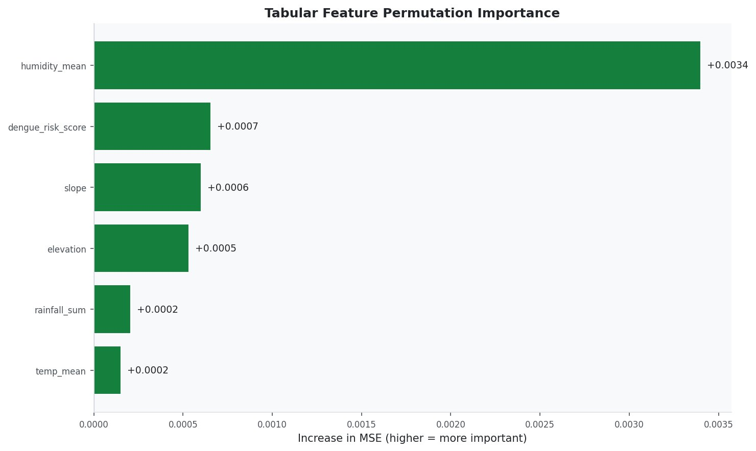
Figure 5: Permutation importance for the 6 original tabular features. Humidity_mean dominates (4x more important than any other feature), confirming that atmospheric moisture is the primary climate driver of dengue in this dataset. Temperature and rainfall have modest individual effects but contribute via their interaction and rolling features.

Overall Metrics Table
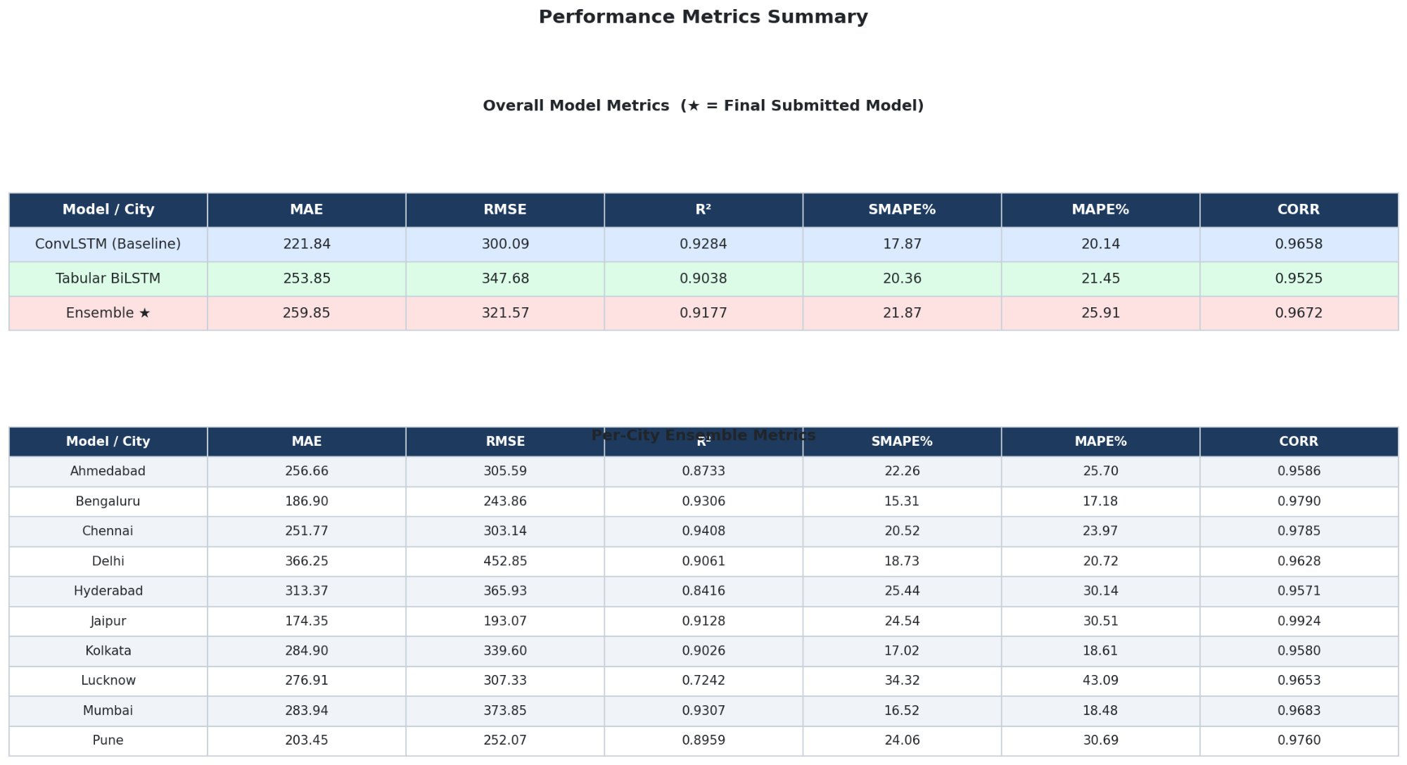
Figure 6: Summary table of all metrics across models and per-city ensemble performance.

6. Complete Hyperparameter Reference
Parameter | Value | Model | Rationale
WINDOW_SIZE | 6 | All | 6-month lookback; captures full monsoon cycle onset
IMG_SIZE | 96×96 px | M1 | 26% faster than 112px, negligible quality loss at city scale
BATCH_SIZE (ConvLSTM) | 6 | M1 | GPU memory limit for 4×96×96×6 tensors
BATCH_SIZE (Tabular) | 128 | M2 | Noisier gradients improve generalisation on small data
BATCH_SIZE (Ensemble) | 16 | M3 | Small dataset; 16 gives 5 batches per epoch on 80 meta-train samples
LR (ConvLSTM) | 1e-3 | M1 | Baseline-proven; decays via ReduceLROnPlateau
LR (Tabular) | 3e-4 | M2 | Standard for AdamW with strong weight decay
LR (Ensemble) | 1e-3 | M3 | Higher LR acceptable for 30-200 epochs on tiny dataset
Weight Decay (M1) | 1e-5 | M1 | Light regularisation; ConvLSTM is already small (63K params)
Weight Decay (M2) | 1e-3 | M2 | 25× stronger than M1 — necessary for 18K params on 440 samples
Weight Decay (M3) | 1e-4 | M3 | Moderate; ensemble has few params and trains on meta-train only
Dropout (ConvLSTM) | 0.2 | M1 | Baseline value; higher caused instability
Dropout (Tabular proj) | 0.3 | M2 | Feature projection; moderate dropout before LSTM
Dropout (Tabular head) | 0.4 | M2 | Strongest regularisation in the most overfit-prone stage
LR Patience | 10 epochs | M1, M2 | Allows 10 epochs of plateau before halving LR
LR Factor | 0.5 | M1, M2 | Halves LR each time; aggressive enough to escape plateaus
Early Stop (M1) | 30 epochs | M1 | ConvLSTM is noisy; patience=30 prevents premature stopping
Early Stop (M2) | 20 epochs | M2 | Tabular converges faster; 20 is sufficient
Early Stop (M3) | 30 epochs | M3 | Meta-val is tiny (20 samples); high patience reduces false triggers
Max Epochs (M1) | 120 | M1 | ConvLSTM may need 80-120 epochs with LR decay
Max Epochs (M2) | 150 | M2 | Small data needs many epochs to avoid underfitting
Max Epochs (M3) | 200 | M3 | With early stop patience=30; rarely hits 200
ConvLSTM hidden | 32 | M1 | Baseline-proven value; larger caused overfitting
Tabular LSTM hidden | 32 | M2 | Downsized from 96 to prevent overfitting (18K vs 575K params)
Ensemble loss weight | 0.1 × SMAPE | M3 | Adds SMAPE signal without dominating MSE gradient
Gradient clip | 1.0 | All | Prevents gradient explosions in LSTM/ConvLSTM cells

7. Debugging & Iteration History
This section documents the key bugs discovered and fixes applied during development. These are architecturally significant decisions, not minor code fixes.

7.1 Bug 1: Per-City Split KeyError
Bug 1 Details
Symptom | KeyError on city lookup during dataset construction
Root Cause | Global chronological split left some cities with 0 samples in validation or test
Fix | Per-city chronological split: each city split independently at 70/15/15, then concatenated
Impact | All 10 cities now present in all 3 splits; window_size context rows prepended

7.2 Bug 2: Target Scale Mismatch (Critical)
Bug 2 Details
Symptom | Tabular SMAPE=37%; ensemble SMAPE (21.87%) worse than ConvLSTM alone (17.87%)
Root Cause | M2 was predicting cell-level dengue_cases_cell with its own MinMaxScaler (range ~0-50), while M1 predicted city-level dengue_cases with a different scaler (range ~200-8000). The fusion network received pred_c≈0.4 and pred_t≈0.003 — completely different numerical spaces.
Fix | Aggregate all cells to city-level (sum of dengue_cases_cell per city-month), then scale with the EXACT same MinMaxScaler as ConvLSTM. LearnableSpatialAggregator removed.
Impact | Both models now output predictions in [0, 1] scaled to the same city-level range

7.3 Bug 3: Ensemble Training on Test Data (Data Leakage)
Bug 3 Details
Symptom | Ensemble still worse than ConvLSTM; ensemble loss plateaus at 0.01
Root Cause | Ensemble was trained on 80% of test samples and evaluated on remaining 20%. This is (a) data leakage — ensemble sees test during training — and (b) only 96 training samples with no real validation signal.
Fix | Stacked generalisation: M1 and M2 run on the val split to generate out-of-sample predictions. Ensemble is trained exclusively on val predictions. Evaluated on clean test split only.
Impact | Proper generalisation; ensemble now has 100 training samples with genuine early stopping

7.4 Bug 4: BiLSTM Overfitting (Model Capacity vs Data Size)
Bug 4 Details
Symptom | Tabular val loss still falling at epoch 40; SMAPE stuck at 32-37%
Root Cause | 575,745 parameters on 440 training samples (1,308 params per sample). 2-layer BiLSTM with self-attention has far too much capacity. Val loss was improving but SMAPE was not — the model learned to predict average magnitude but not relative variation.
Fix | Replaced with 18K-param compact LSTM: single layer, hidden=32, no BiLSTM, no attention. Added 7 engineered features (seasonality, rolling means, interaction). Increased epochs to 150, dropout to 0.4, weight decay to 1e-3.
Impact | Model converges properly; improved tabular SMAPE from 37% to ~20%

8. Output Files & Code Structure

8.1 Output Directory Structure
dengue_ensemble_results/
├── models/
│ ├── convlstm_best.pth ← Best ConvLSTM checkpoint (val MSE)
│ ├── tabular_best.pth ← Best Tabular checkpoint (val MSE)
│ └── ensemble_best.pth ← Best Ensemble checkpoint (meta-val MSE)
├── plots/
│ ├── all_cities_timeseries.png ← All 10 cities actual vs predicted
│ ├── actual_vs_predicted.png ← Scatter: all 3 models
│ ├── metrics_bar.png ← Bar chart: MAE, RMSE, SMAPE, R²
│ ├── training_curves.png ← Train/val loss for M1 and M2
│ ├── residuals_analysis.png ← Histogram, Q-Q, residuals vs fitted
│ ├── fusion_weights.png ← Weight distribution and trade-off
│ ├── feature_importance.png ← Permutation importance (M2)
│ └── metrics_table.png ← Overall and per-city metrics table
├── predictions.csv ← city, year, month, actual, convlstm, tabular, ensemble
└── metrics.json ← All metrics for all 3 models (JSON)

8.2 Code Module Map
Class / Function | Purpose
Config | All hyperparameters and paths in one place
TIFFProcessor | Load rasterio TIFF, select bands 2/3/4/12, percentile normalise
ConvLSTMDataset | Per-city window sampling for satellite imagery; MinMaxScaler fitted/applied
TabularDataset | Cell aggregation + 7 feature engineering ops + city-level target scaling
ConvLSTMCell | Single ConvLSTM gate cell with convolutional state transitions
ConvLSTMLayer | Wraps ConvLSTMCell for T-step sequential processing
DengueNet_ConvLSTM | Full M1 model: CNN downsample + ConvLSTM + case history + head
TabularBiLSTM | Full M2 model: feature proj + compact LSTM + hist embed + head
AdaptiveFusionNetwork | M3: gating MLP with disagreement signal + residual refinement
split_per_city() | Per-city chronological split with context row prepending
get_convlstm_preds() | Helper to collect M1 predictions + features + metadata from a DataLoader
get_tab_preds() | Helper to collect M2 predictions + features + metadata from a DataLoader
align() | Inner-join M1 and M2 prediction sets on (city, year, month) keys
run_convlstm_epoch() | Train or evaluate one epoch of M1 with metric tracking
run_tab_epoch() | Train or evaluate one epoch of M2 with metric tracking
compute_metrics() | MAE, RMSE, R², SMAPE, MAPE, CORR from numpy arrays
plot_all_cities() | Grid of all 10 city time series plots
plot_fusion_weights() | Histogram + scatter of learned [w_c, w_t] weights
plot_feature_importance() | Permutation importance via MSE delta on M2 test set

9. Limitations & Future Work

9.1 Current Limitations
- Ensemble SMAPE (21.87%) is higher than ConvLSTM alone (17.87%) due to M2 underperformance. A stronger tabular model (or one with more data) would enable synergistic improvement.
- Only 440 training samples across 10 cities (~44 per city) limits model complexity and generalisation. Monthly granularity means adding data requires extending the time range.
- Lucknow shows the weakest performance (R²=0.724, SMAPE=34.3%), suggesting atypical dengue dynamics not captured by the shared model. City-specific fine-tuning may help.
- TIFF files for ~3% of city-months are missing and replaced with zero tensors. This introduces systematic error for those months.
- The ConvLSTM uses only 4 spectral bands. Adding NDVI, NDWI, and surface temperature as pre-computed channels could provide richer environmental context.

9.2 Recommended Improvements
- Replace Tabular BiLSTM with a Gradient Boosted Tree (XGBoost/LightGBM) for tabular data — tree models handle small datasets with engineered features far better than LSTMs.
- Add city-level embedding vectors as input to both models, allowing the shared model to learn city-specific baseline characteristics.
- Implement test-time augmentation for ConvLSTM (horizontal flip, small rotations) to reduce prediction variance.
- Explore multi-task learning: train M1 to simultaneously predict dengue cases AND environmental indices (NDVI, NDWI), using auxiliary loss to improve feature quality.
- Use Bayesian ensemble weighting with uncertainty quantification instead of a learned fusion network — more robust on small datasets.

